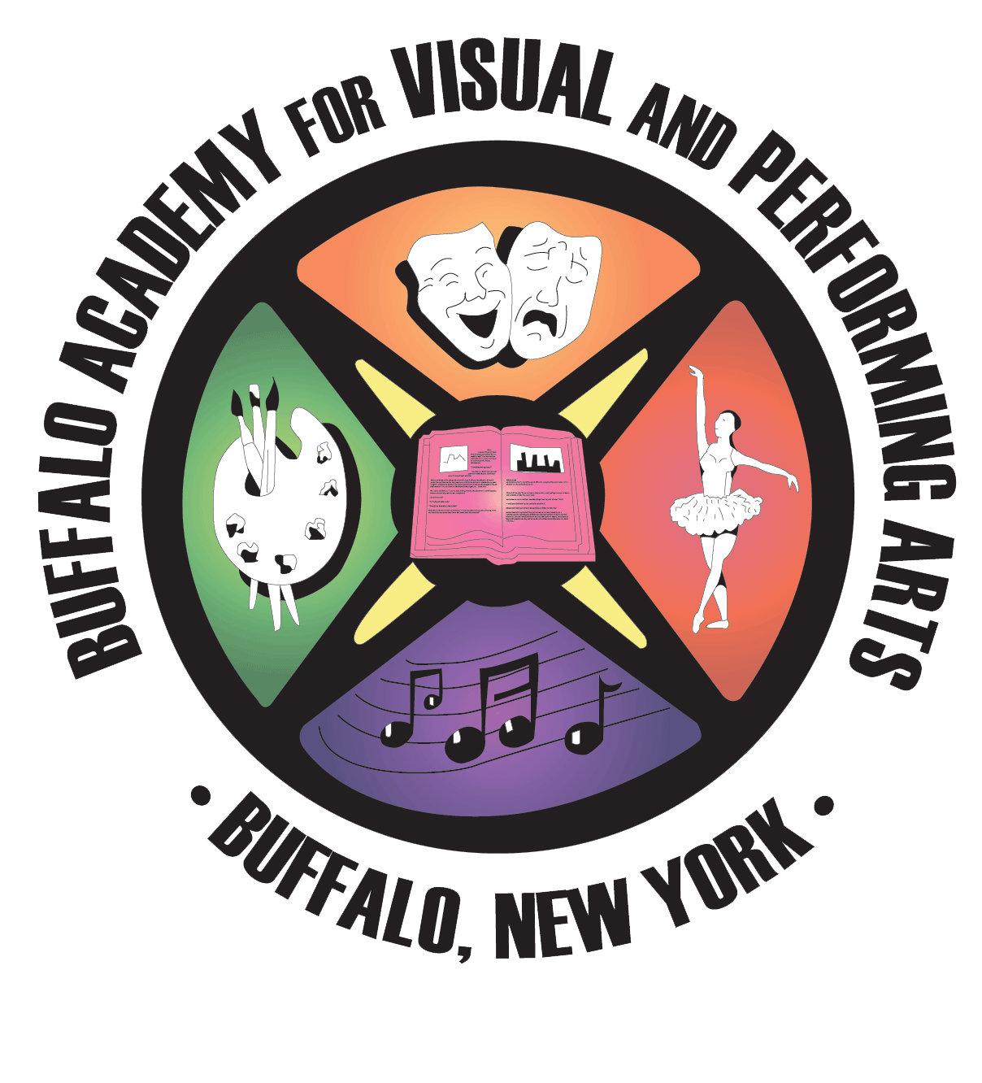**Buffalo Academy for Visual and Performing Arts**

### **450 Masten Avenue Buffalo, NY 14209**

**Tel.: (716) 816-4220 Fax: (716) 888-7136**

[www.buffaloartsacademy.org](http://www.buffaloartsacademy.org/)

**STUDENT PROFILE FORM**

Grade Levels 5 - 8

### **SEPTEMBER 2026-2027** SCHOOL YEAR

 

|  |  |
| --- | --- |
| **1. Student's First Name:** |  |
| **2. Student's Last Name:** |  |
| **3. Are you a current BPS student:** |  |
| **4. What school do you currently attend:** |  |
| **5. What art form are you auditioning for:** Select from options on back for Question #5 |  |
| **6. If Instrumental, What Instrument(s):** |  |
| **7. Grade level entering in Sept. 2026:** |  |
| **8. Email address for student:** |  |
| **9. Phone Number for student:** |  |
| **10. Student's Address** (House# & Street): |  |
| **11. Student's Address** (City, State, Zip): |  |
| **12. Date of Birth** (month *I* day/ year): |  |
| **13. Gender Sex** (Legal - Male or Female): |  |
| **14. Gender Identity:**  (Male, Female, or Other): |  |
| **15. Ethnicity:**  Select from options on back for Question #15 |  |
| **16. Does the student have an I.E.P:**  (Individualized Education Plan) |  |
| **17. Primary Parent or Guardian Name:** |  |
| **18. Phone Number for Parent/Guardian:** |  |
| **19. Email address for Parent/Guardian:** |  |
| **20. Audition Date you plan to attend:** Select from options on back for Question #20 |  |

**Mail, Fax or submit In-Person the completed *Student Profile Form* to:**

**Buffalo Academy for Visual and Performing Arts - 450 Masten Avenue, Buffalo NY 14209**

ATTENTION: ADMISSIONS – Fax #: (716) 888-7136

### This form can also be emailed to [info@buffaloartsacademy.org](mailto:info@buffaloartsacademy.org?subject=Audition%20Submission)

*Reference Guide for answering questions located on the front page*

**Questions #5** - **What Artistic Area of Specialization is the student auditioning for?**

Choose from the following list of Artistic Areas to fill in the space for Question #5 on the front page.

If a student wants to audition for more than one Artistic Area of specialization, the student must complete a separate Student Profile Form for each Artistic Area.

Artistic Areas of Specialization offered at the Arts Academy for Grades 9 thru 12

**DANCE**

**INSTRUMENTAL MUSIC**

**THEATRE**

**VISUAL ART**

**VOCAL MUSIC**

**Questions #15** - **What is the students Ethnicity or Race?**

Choose from the following list of Ethnicities to fill in the space for Question #15 on the front page.

List of Ethnicities

**AFRICAN AMERICAN**

**ARABIC**

**ASIAN or PACIFIC ISLANDER**

**HISPANIC**

**NATIVE AMERICAN**

**WHITE or CAUCASIAN**

**OTHER**

**Questions #20** - **What Audition Date do you plan to attend?**

Choose one of the following Audition Dates to fill in the space for Question #20 on the front page.

In-Person Audition Dates

**SATURDAY, NOVEMBER 15, 2025**

**SATURDAY, NOVEMBER 22, 2025**

**Additional Audition Information**

* In-Person Auditions are held at the Buffalo Academy for Visual and Performing Arts located at

## 450 Masten Avenue, Buffalo, NY 14209

* **All applicants must report for their audition at 8:00 AM sharp!**

#### Bring your most recent report card and any requirements needed for your artistic area.

* Go to the school's website at [www.buffaloartsacademy.org/admissions-process](https://www.buffaloartsacademy.org/admissions-process) for audition

requirements & information.

* Students will be enrolled into a *Schoology Audition Course* to submit material prior to the audition.
* Each applicant must complete this Arts Academy *Student Profile Form* and a Buffalo Public Schools 2026-2027 High School Application located on the BPS Website at -[www.buffaloschools.org](http://www.buffaloschools.org/)

# * PLEASE NOTE: Acceptance is based on successful completion of your current grade and having met all areas of criteria for the audition process.

**ARTS ACADEMY AUDITION REQUIREMENTS – INFORMATION and CONFIRMATIONS**

1. You understand that you will be entered into a Schoology Audition Course on-line and will need access to a computer with internet. This course is where students will complete assignments and upload audition materials for our panel of teachers to review if it is required by the artistic area *

Yes

1. You understand you will need to submit your most recent report cards and complete all requirements needed for your artistic area of specialization. The Audition Requirements for each artistic area can be found on the school's website – [**www.buffaloartsacademy.org/admissions-process**](http://www.buffaloartsacademy.org/admissions-process) *

Yes

1. You understand that acceptance to the Buffalo Academy for Visual and Performing Arts is based on the successful completion of your current grade and having met all the areas of criteria for the audition. *

Yes

1. You understand that any video or artwork submitted to the Buffalo Academy for Visual and Performing Arts remains the property of you (the student) and will only be used by the school in assessing your artistic abilities. *

Yes

1. You understand that each student auditioning must ALSO complete a Buffalo Public Schools

- High School Application for the 2026-27 school year located on the BPS website – [www.buffaloschools.org](https://www.buffaloschools.org/o/dept-admissions-registration/page/admissions-registration/) - under the Admissions & Registration Department section. The BPS High School Application contains a Recommendation Form with pages specifically for the Buffalo Academy for Visual and Performing Arts. *

Yes

1. To be officially accepted to the Dance Department, you understand that dance students must have a doctor's clearance stating their ability to fully participate without physical restriction in every aspect of the Dance Curriculum.

Skip this question if you are not auditioning for Dance.

Yes

1. You understand that once you submit this Student Profile Form, it will be automatically received by the school for processing. The next step will be to prepare for your audition by checking the Audition Requirements and then arrive at the Arts Academy at 450 Masten Avenue at 8:00 AM for the In-Person Audition on the date you have selected. *

Yes

1. If you have any questions or concerns, you may email your questions to our school at [info@buffaloartsacademy.org](mailto:info@buffaloartsacademy.org) or call our Main Office at (716) 816-4220.*

Yes. I will email or call the school with my question.

No. I do not have any questions or concerns at this time.